|  |  |  |  |  |  |  |  |  |
| --- | --- | --- | --- | --- | --- | --- | --- | --- |
|  |  | MAE | MAPE | MSE | RMSE | RSquared | NRMSE | CVRMSE |
| LSTM | 5-1 | 63.78 | 0.075 | 6655.33 | 81.58 | 0.49 | 0.0061 | 0.0050 |
| 10-1 | 62.59 | 0.072 | 6366.73 | 79.79 | 0.55 | 0.0059 | 0.0049 |
| 10-3 | 69.97 | 0.0844 | 7882.22 | 88.78 | 0.41 | 0.0066 | 0.0055 |
| 20-5 | 78.53 | 0.094 | 10044 | 100.22 | 0.3746 | 0.0074 | 0.0062 |
| 30-7 | 81.46 | 0.096 | 10974 | 104.76 | 0.3991 | 0.0078 | 0.0064 |
| FNN | 5-1 | 61.98 | 0.075 | 6484.00 | 80.52 | 0.52 | 0.0060 | 0.0050 |
| 10-1 | 72.70 | 0.086 | 8408.28 | 91.70 | 0.4301 | 0.0068 | 0.0056 |
| 10-3 | 83.55 | 0.1006 | 11154 | 105.61 | 0.2248 | 0.0078 | 0.0065 |
| 20-5 | 130.78 | 0.1546 | 24283 | 155.83 | 0.1394 | 0.0116 | 0.0096 |
| 30-7 | 131.50 | 0.1505 | 24376 | 156.12 | 0.2851 | 0.0116 | 0.0096 |

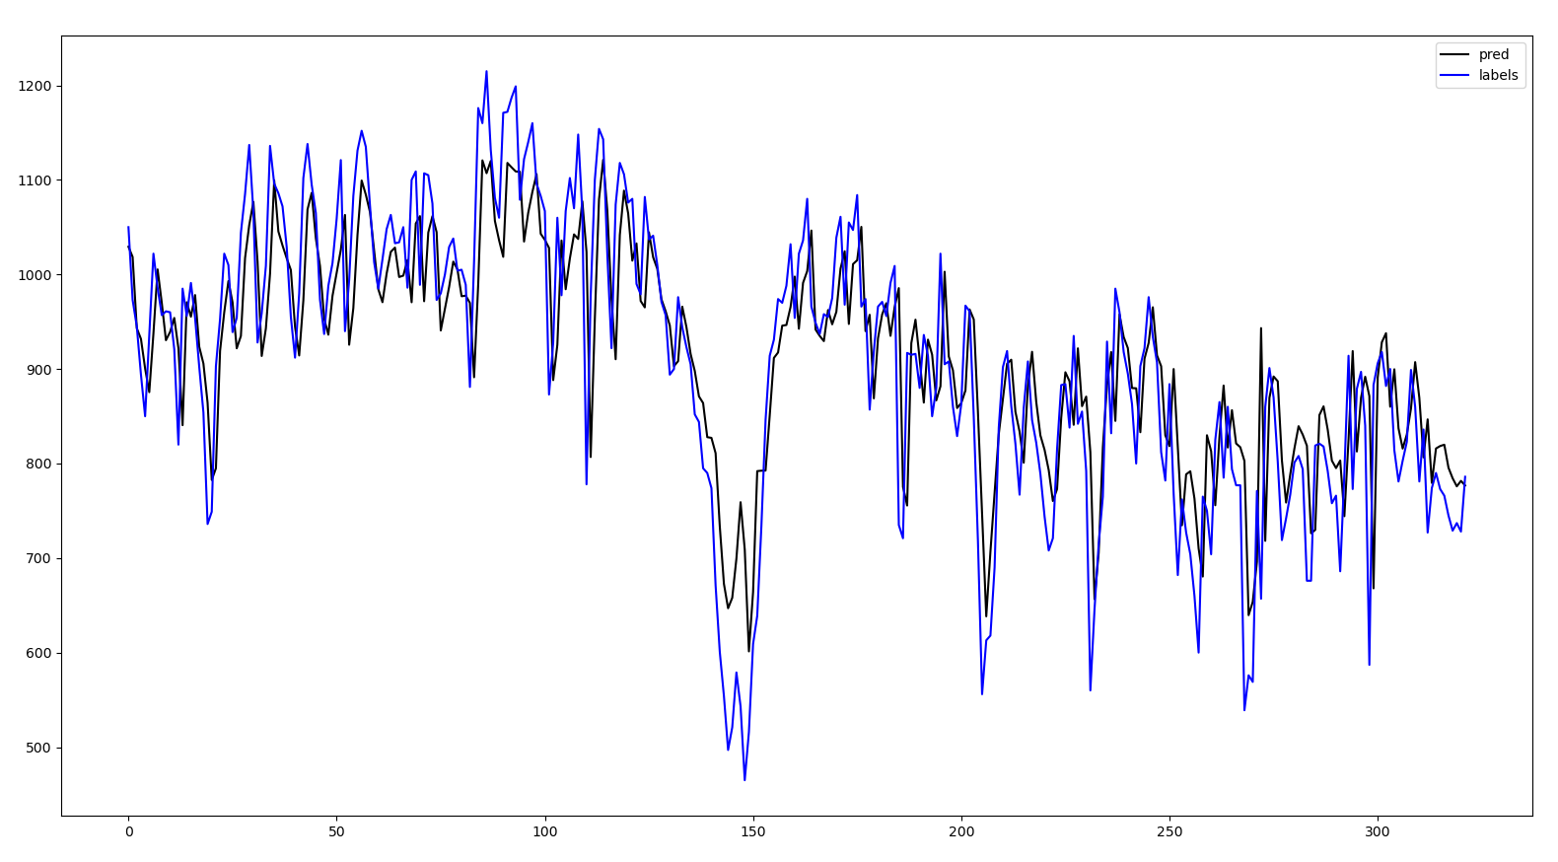

5-1

上为LSTM

下为FNN

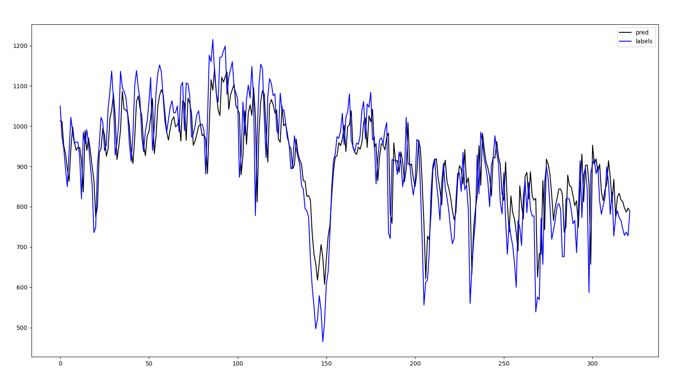

A

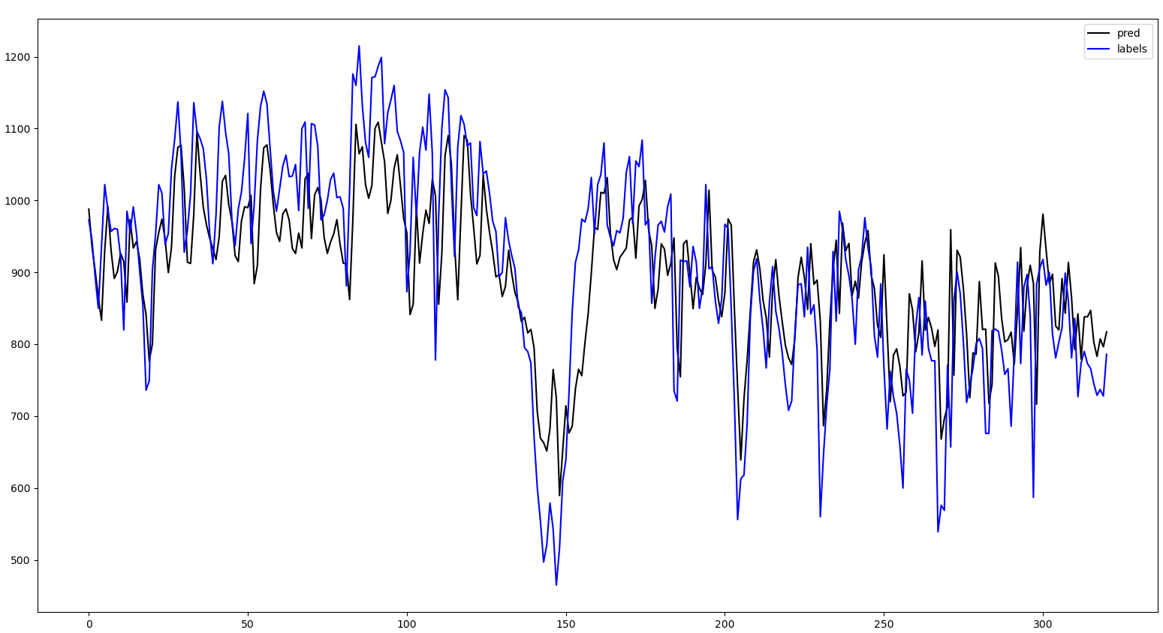

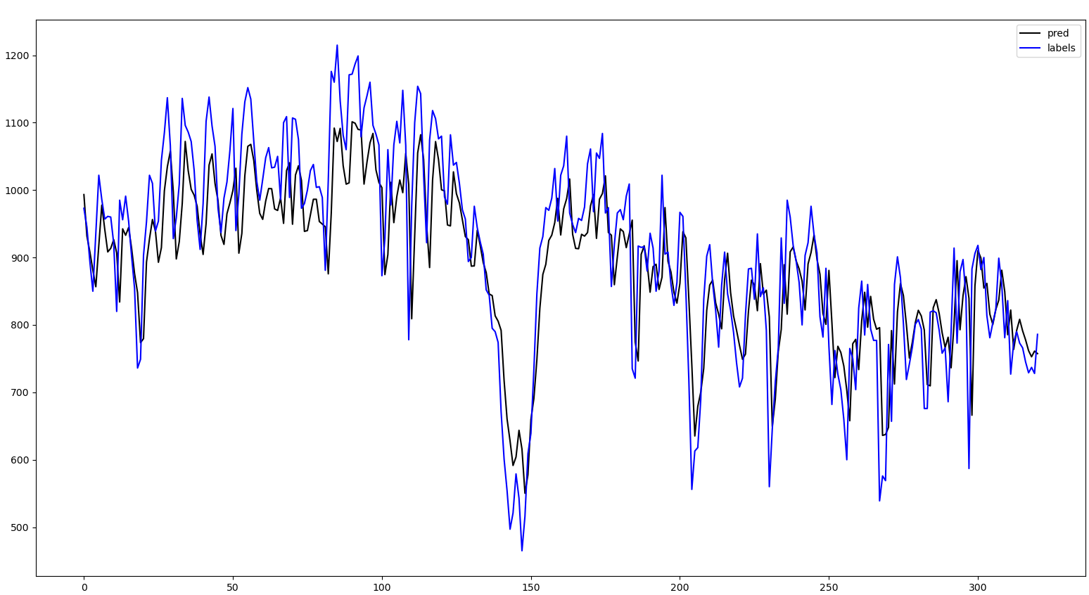

10-1

10-3

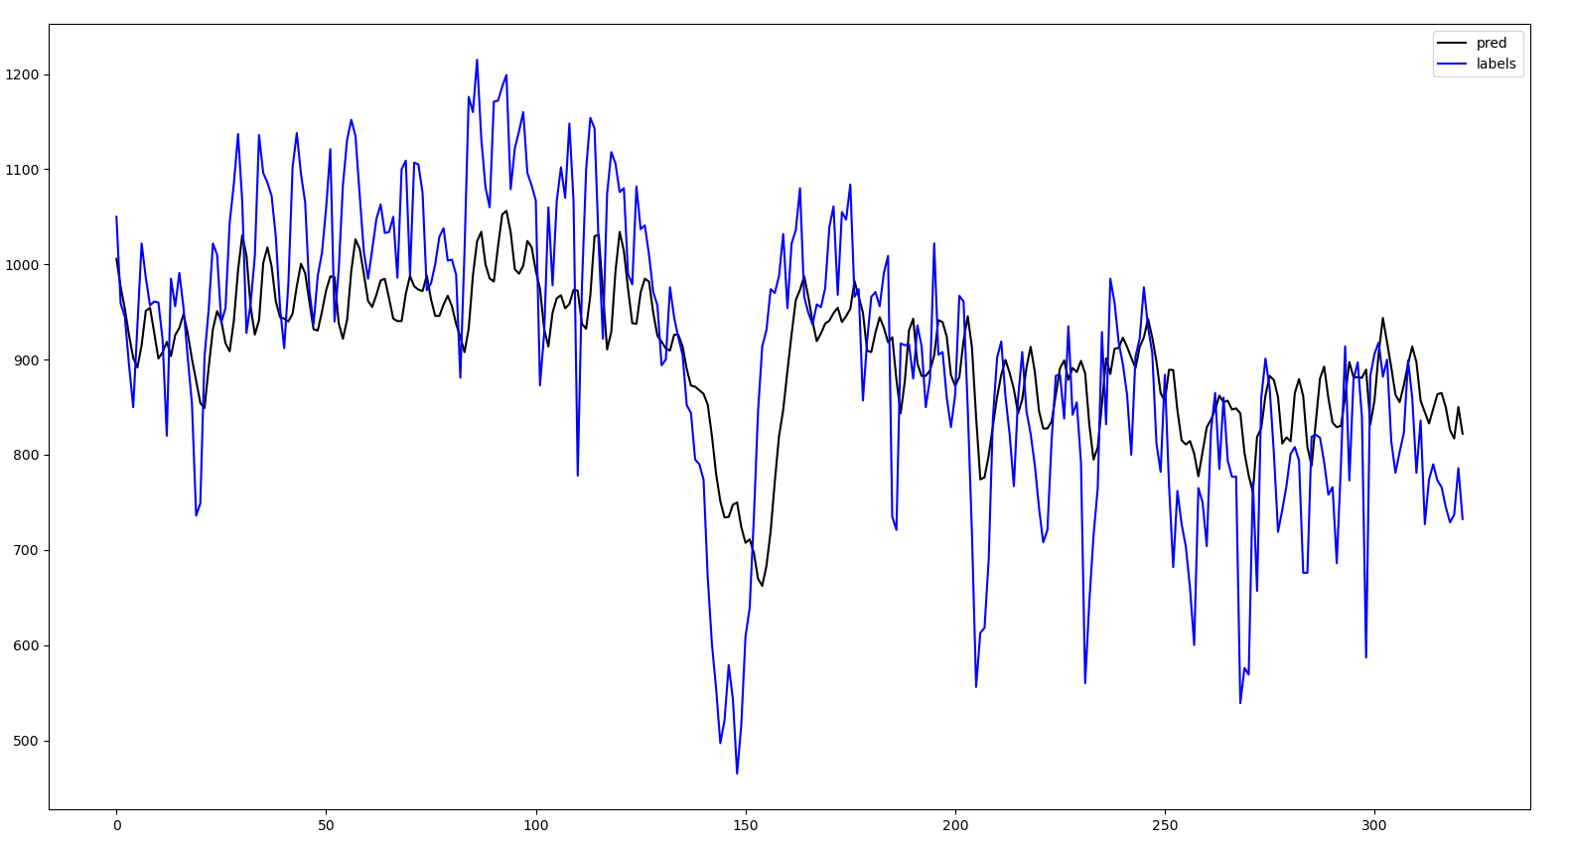

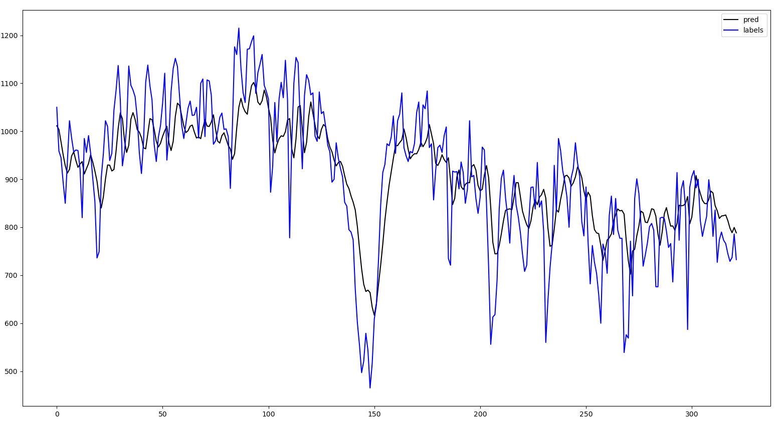

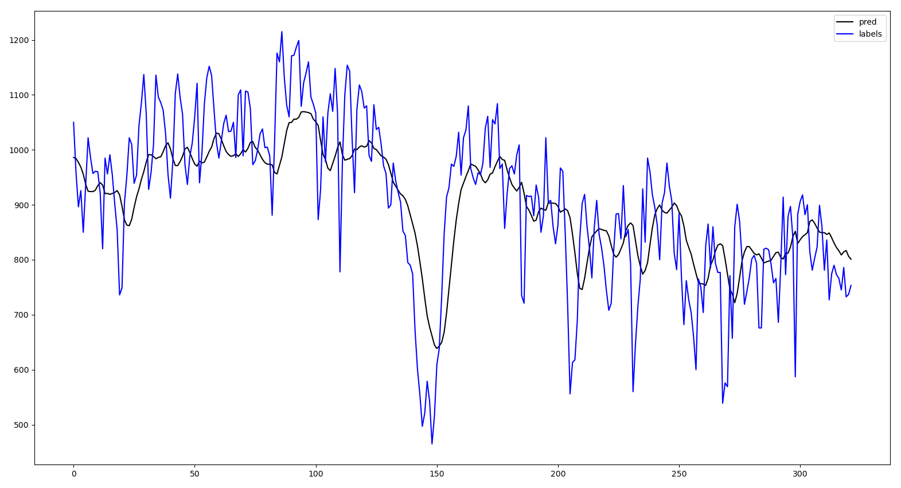

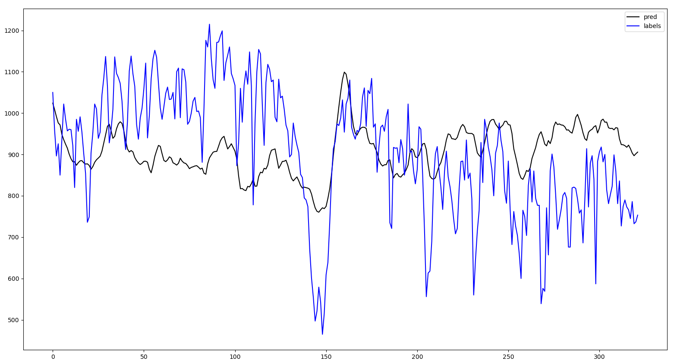

20-5

30-7

